**M.C.T.V User Guide**

**User Guide – Sage Cloud/Sage50**

***By Nathan Hodgkiss – x17381176***

**Introduction:**

Sage is an accounting software, it is an integrated accounts package. For this user guide we will be examining the sales invoice & payroll part of Sage. I will be providing screenshots to illustrate my points.

**Overview – Sales:**

Sales orders let you enter items for a customer, you can then invoice and later ship the items as they become available in your inventory, tracking any backorders in the system.

**Instructions – Entering a Sales Invoice:**

* From the tasks menu, select Quotes/Sales Orders then select Sales Orders from the submenu.

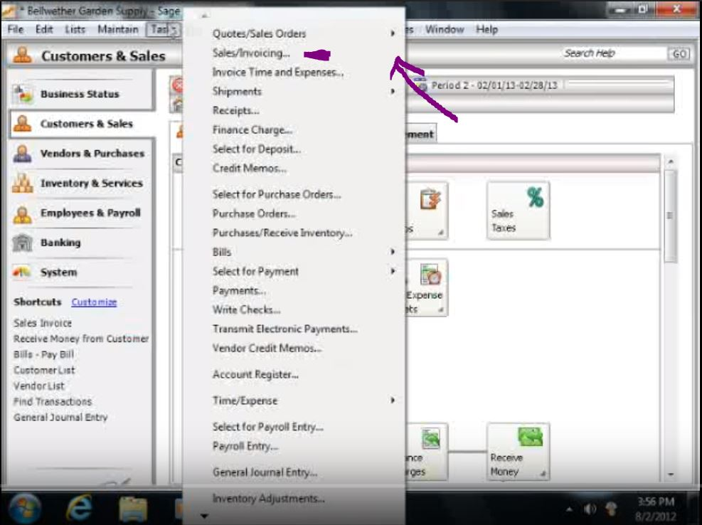

* Enter the customer ID.
* Enter the sales order if you wish to change the one that Sage automatically generated.
* Enter the date of the sales order.
* Enter the date that the order should be shipped by.
* If necessary, change the shipping address, if not leave the field as it appears.
* You may the change the shipping method if necessary by clicking the “Ship via” button.

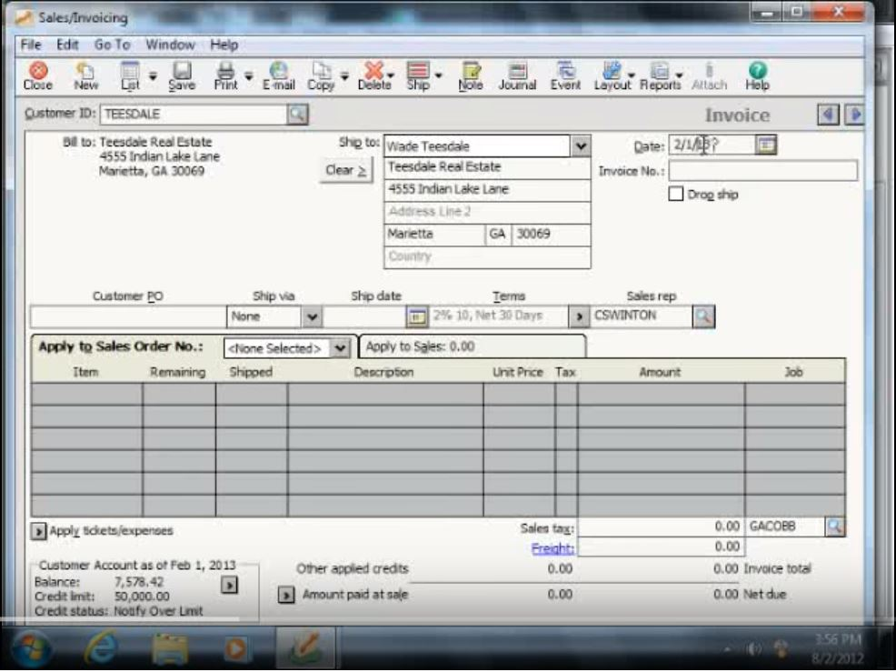

* You can then change the “terms” of the order if you wish to apply a discount to the customer order, by clicking the Terms button.
* Next, you must enter the code of the customers sales representative.
* You must then enter the information for each item on the sales order.
* Click attach to add documents or pictures to the sales orders.
* Select the sales tax ID for this sale.
* If you wish to charge for freight, include an amount in the Freight field.

**Overview – Payroll:**

Payroll is the process of paying your employee’s their wages over a set period of time.

**Instructions – Payroll (Group):**

* From the Task menu, click on Select for Payroll Entry.
* Choose the pay frequencies, pay types & range of employees.
* You may then edit the payroll for individual employees from the window that Sage displays.
* You may then enter the dates for the checks.

